Assignment 3 if for while conditions structure

**Task 1** 4 LEDs are connected to Arduino Uno, try to use for cycle structure to make a 1s shift effect.

任务1 使用4个LED连接至Arduino Uno，尝试使用for循环结构，实现1s位移点亮的效果。

Answer:

int LEDblue=5;

int LEDred=4;

int LEDyellow=3;

int LEDgreen=2;

void setup()

{

pinMode(LEDblue, OUTPUT);

pinMode(LEDred, OUTPUT);

pinMode(LEDyellow, OUTPUT);

pinMode(LEDgreen, OUTPUT);

}

void loop()

{

for(int x=0; x<4; x++){

digitalWrite(LEDblue,HIGH);

delay(1000);

digitalWrite(LEDblue,LOW);

digitalWrite(LEDred,HIGH);

delay(1000);

digitalWrite(LEDred,LOW);

digitalWrite(LEDyellow,HIGH);

delay(1000);

digitalWrite(LEDyellow,LOW);

digitalWrite(LEDgreen,HIGH);

delay(1000);

digitalWrite(LEDgreen,LOW);

}

}

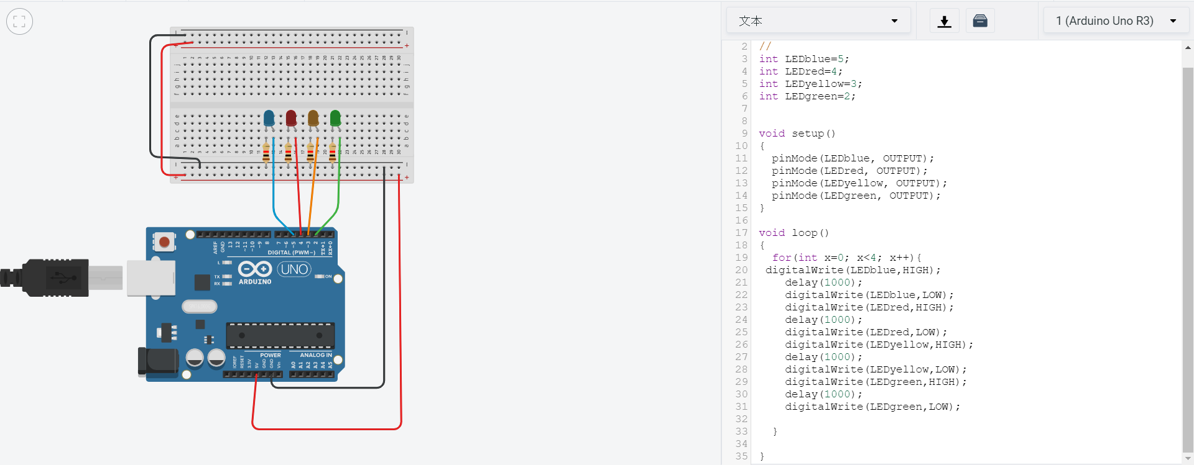

**Task 2** One LED and a POT are connected to Arduino, define a function named getVoltage to calculate the real time voltage of the POT, if the value is larger than 2.5V, then turn on the LED.

任务2 一个LED和一个电位器与Arduino Uno相连，定义一个函数名为getVoltage，用于计算POT段子的实时电压，若电压大于2.5V，则点亮LED。

Answer:int ledpin=3;

int potpin =A0;

int sensorValue =0;

int value=analogRead(potpin);

float getVoltage=value/1024*5;

void setup()

{

pinMode(ledpin, OUTPUT);

pinMode(potpin,INPUT);

Serial.begin(9600);

}

void loop()

{

sensorValue=analogRead(A0);

if (getVlotage()>2.5)

{

digitalWrite(ledpin,HIGH);

}

else {

digitalWrite(ledpin,LOW);

}

}

